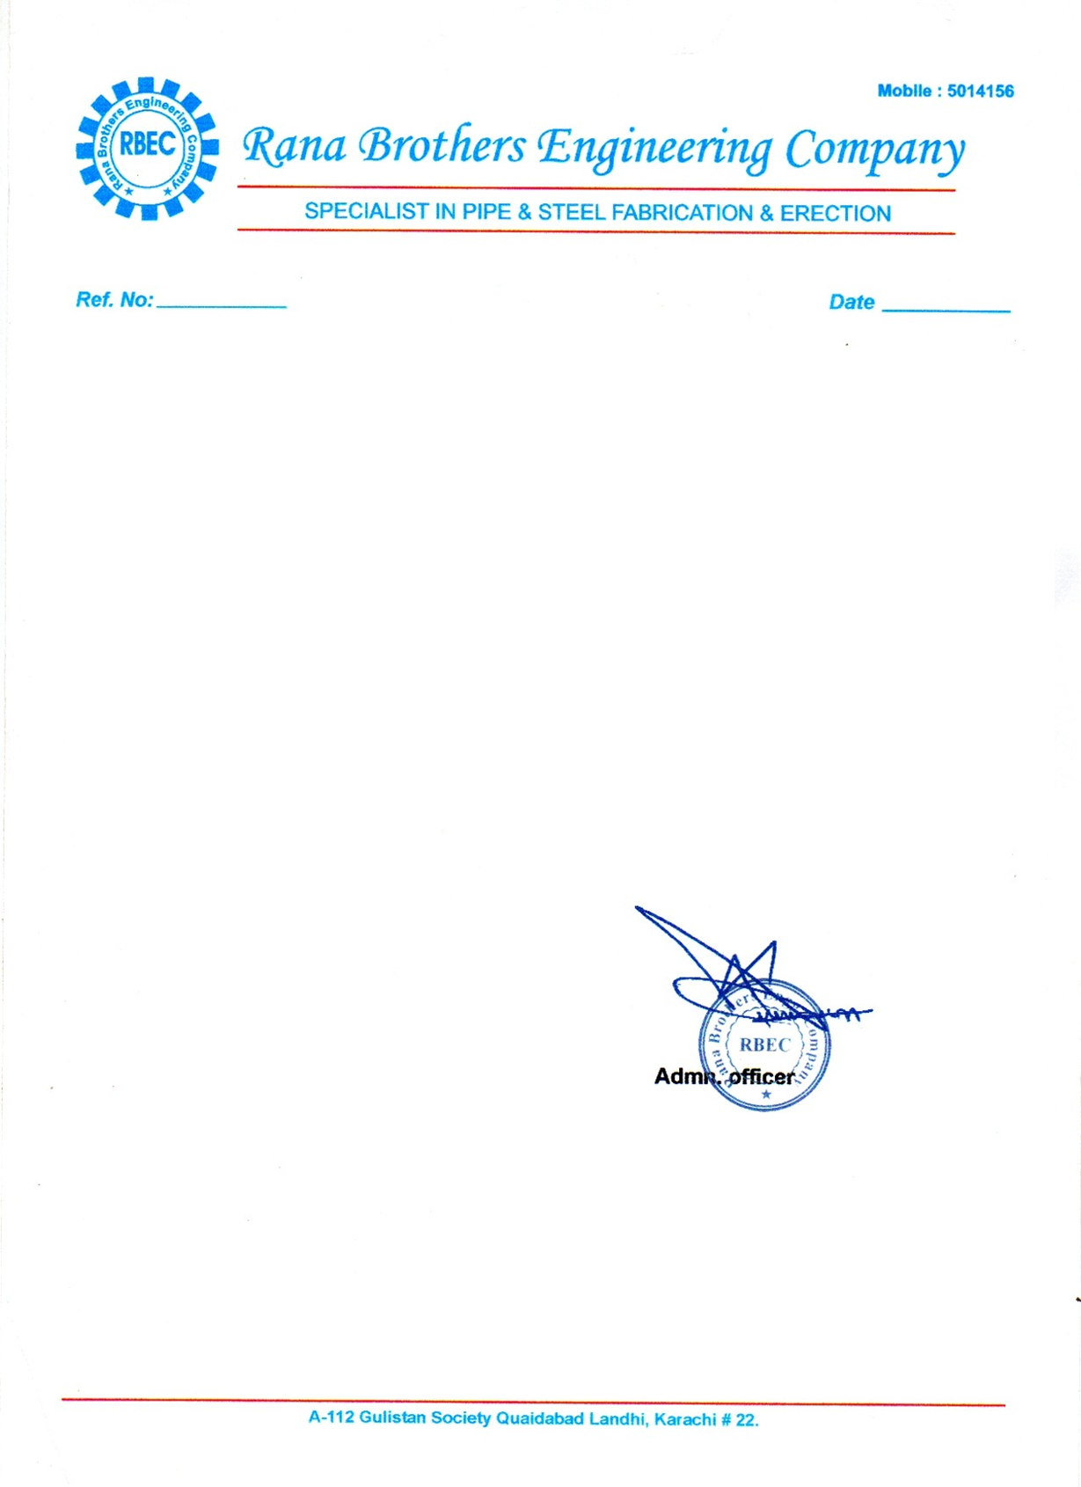

<To2>

TO WHOM IT MAY CONCERN

This is to certifying that Mr. <Name> S/o <fname> has been working with our organization as <Designation> from <From2> to <To2> at Project I.C.I. Karachi.

During this tenure we found him honest, punctual and hard working young man.

We wish him every success in his future life.